**Assignment*- VIPIN PRAJAPAT***

***1.What is software? What is software engineering?***

*Ans.*

*Software:-*

*Software is****a set of instructions, data or programs used to operate computers and execute specific tasks****. It is the opposite of hardware, which describes the physical aspects of a computer.*

*Software Engineering:-*

*Software engineering is the application of principles used in the field of engineering, which usually deals with physical systems, to the design, development, testing, deployment and management of software systems*.

***2. Explain types of software?***

**Examples and types of software**

Among the various categories of software, the most common types include the following:

* **Application software.**The most common type of software, application software is a computer software package that performs a specific function for a user, or in some cases, for another application. An application can be self-contained, or it can be a group of programs that run the application for the user. Examples of [modern applications](https://www.techtarget.com/searchcio/feature/The-rise-of-modern-applications-Why-you-need-them) include office suites, graphics software, databases and database management programs, web browsers, word processors, software development tools, image editors and communication platforms.
* **System software.** These software programs are designed to run a computer's application programs and hardware. System software coordinates the activities and functions of the hardware and software. In addition, it controls the operations of the computer hardware and provides an environment or platform for all the other types of software to work in. The OS is the best example of system software; it manages all the other computer programs. Other examples of system software include the [firmware](https://www.techtarget.com/whatis/definition/firmware), computer language translators and system [utilities](https://www.techtarget.com/whatis/definition/utility).
* **Driver software.**Also known as device drivers, this software is often considered a type of system software. Device drivers control the devices and peripherals connected to a computer, enabling them to perform their specific tasks. Every device that is connected to a computer needs at least one device driver to function. Examples include software that comes with any nonstandard hardware, including special game controllers, as well as the software that enables standard hardware, such as USB storage devices, keyboards, headphones and printers.
* **Middleware.**The term *middleware* describes software that mediates between application and system software or between two different kinds of application software. For example, middleware enables Microsoft Windows to talk to Excel and Word. It is also used to send a remote work request from an application in a computer that has one kind of OS, to an application in a computer with a different OS. It also enables newer applications to work with legacy ones.
* **Programming software.** Computer programmers use programming software to write code. Programming software and programming tools enable developers to develop, write, test and [debug](https://www.techtarget.com/searchsoftwarequality/definition/debugging) other software programs. Examples of programming software include assemblers, compilers, debuggers and interpreters.

***3.What is SDLC? Explain each phase of SDLC***

# SDLC Models

*Software Development life cycle (SDLC) is a spiritual model used in project management that defines the stages include in an information system development project, from an initial feasibility study to the maintenance of the completed application.*

*There are different software development life cycle models specify and design, which are followed during the software development phase. These models are also called "****Software Development Process Models****." Each process model follows a series of phases unique to its type to ensure success in the step of software development.*

#### 7 Stages of the System Development Life Cycle

There are seven primary stages of the modern system development life cycle. Here’s a brief breakdown:

* Planning Stage
* Feasibility or Requirements of Analysis Stage
* Design and Prototyping Stage
* Software Development Stage
* Software Testing Stage
* Implementation and Integration
* Operations and Maintenance Stage

Phases Of SDLC :-

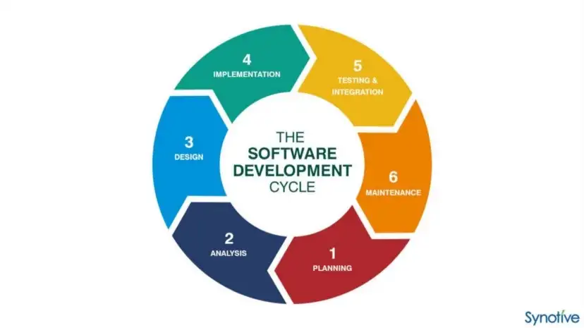

4.What is DFD? Create a DFD diagram on Flipkart?

**Data flow diagram (DFD) is a diagram being used frequently in software design. It visually represents the flow of data throughout processes in a given system. DFD shows the kind of information that will be input to and output from processes as well as where the data will be stored.**

### Purpose of Data Flow Diagrams

A typical information system involves processing a lot of information and processes. The purpose of Data Flow Diagrams is to view systems as a whole with its scopes and boundaries while it illustrates the movement of information between components. The focus of DFD is on the flow of data throughout the system, not process flow. DFD allows readers to easily see how the system will operate by knowing the kind and flow of information involved.

DFD diagram on Flipkart:-

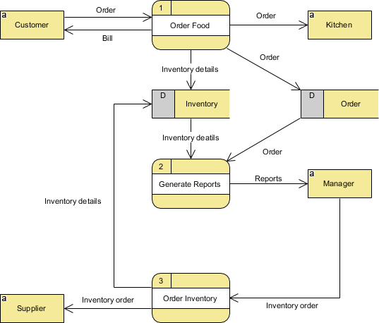There are two main types of DFD: Physical and Logical.

Physical DFD: Focuses on the physical aspect of the system by showing “how” the system will be implemented

Logical DFD: Focuses on a higher-level view of the system and “what” it will achieve.

**5.What is Flow chart?** **Create a flowchart to make addition of two numbers**

*A flowchart is****a diagram depicting a process, a system or a computer algorithm****. It is a diagrammatic representation of the solution to a given problem but, more importantly, it provides a breakdown of the essential steps to solving the problem.*

**Use of a flowchart**

***Following are the uses of a flowchart:***

* It is a pictorial representation of an algorithm that increases the readability of the program.
* Complex programs can be drawn in a simple way using a flowchart.
* It helps team members get an insight into the process and use this knowledge to collect data, detect problems, develop software, etc.
* A flowchart is a basic step for designing a new process or add extra features.
* Communication with other people becomes easy by drawing flowcharts and sharing them.

**flowchart to make addition of two numbers**

INPUT NUMBER 1,NUMBER2

PRINT SUM

SUM=NUMBER1+NUMBER2

**6.What is Use case Diagram? Create a use-case on bill payment on paytm.**

Only static behavior is not sufficient to model a system rather dynamic behavior is more important than static behavior. In UML, there are five diagrams available to model the dynamic nature and use case diagram is one of them. Now as we have to discuss that the use case diagram is dynamic in nature, there should be some internal or external factors for making the interaction.

## **Purpose of Use Case Diagrams**

The purpose of use case diagram is to capture the dynamic aspect of a system. However, this definition is too generic to describe the purpose, as other four diagrams (activity, sequence, collaboration, and Statechart) also have the same purpose. We will look into some specific purpose, which will distinguish it from other four diagrams.

Use case diagrams are used to gather the requirements of a system including internal and external influences. These requirements are mostly design requirements. Hence, when a system is analyzed to gather its functionalities, use cases are prepared and actors are identified.

When the initial task is complete, use case diagrams are modelled to present the outside view.

In brief, the purposes of use case diagrams can be said to be as follows −

* Used to gather the requirements of a system.
* Used to get an outside view of a system.
* Identify the external and internal factors influencing the system.
* Show the interaction among the requirements are actors.

**use-case on bill payment on paytm.**

